

**Theory and Technology of Robotics**

**Course Project:**

**Group members:**

**Yuchen Song, Wei Yan, Jingwen Deng, Minghui Yin, Junjie Li**

**Vm250**

**Summer 2021**

**24/06/2021**

Contents

Abstract 3

1 Introduction 4

2 Concept Design 5

3 Manufacturing 10

3.1 Electronic Control 10

3.1.1 Joystick data processing 13

3.2 Three major parts 15

3.2.1 Mobile device 15

3.2.2 Reloading device 16

3.2.3 Shooting device 17

3.3 Material Selection 18

3.4 Details of Design and Assemble 20

3.4.1 Space Adjustment Mechanism of the Friction Wheel 20

3.4.2 The Ball’s Guiding Track 24

3.4.3 Reloading System 26

4 Cost Estimation 28

4.1 Structure 28

4.2 Power System 29

4.3 Control 30

5 Conclusion 30

6 References 31

7 Nomenclature 32

8 Acknowledgement 33

Appendixes 34

# Abstract

In this project, we first did a concept design, following the instructions from chapter 5 (Conceptual design) in this course, then generated our initial designs, from which we selected one alternative as the blueprint and then manufactured our prototype. Finally, we tested the prototype and improved some defective designs. In the concept design, we made product design specifications (PDS), customer requirements (CRs), engineering characteristics (ECs), and built up a house of quality (HOQ). We used some software like AutoCAD, Solidworks, Cura for designing procedure. In the second step, manufacturing, we made the different components in different ways and different materials (e.g., 3D printing material PLA/ABS, 45#steel and acrylic board). We selected the materials and their related treatment based on what we have learnt in chapter 13 (Materials). As for assembly procedure, referring to chapter 20 (Finishing, joining, and assembly), we mainly used screws and nuts for mechanical assembly, also used some hot melt glue and 502 glue as auxiliary joining process. For electronic control, our group adopted PS2 handle (based on Bluetooth telecommunication protocol) to control our prototype remotely. Last but not least, our group accomplished the project within budget(￥2,500), and we did a cost estimation in the 4th part in this report.

# Introduction

The project for Vm250, Automatic Controlled Metal Trebuchet, sets the goal of designing and manufacturing an automatic controlled trebuchet or catapult, which should be able to shoot the given balls into the basket.

The game set up is shown below. In the starting zone, we are able to load the catapult with certain kind of balls (10 ping-pong balls, 5 rocket balls and 2 tennis balls, different points for different balls). Then, once the car is driven into the shooting zone, no group members can touch it physically. The catapult is required to shoot at least 3 balls at the three red points, one for each.

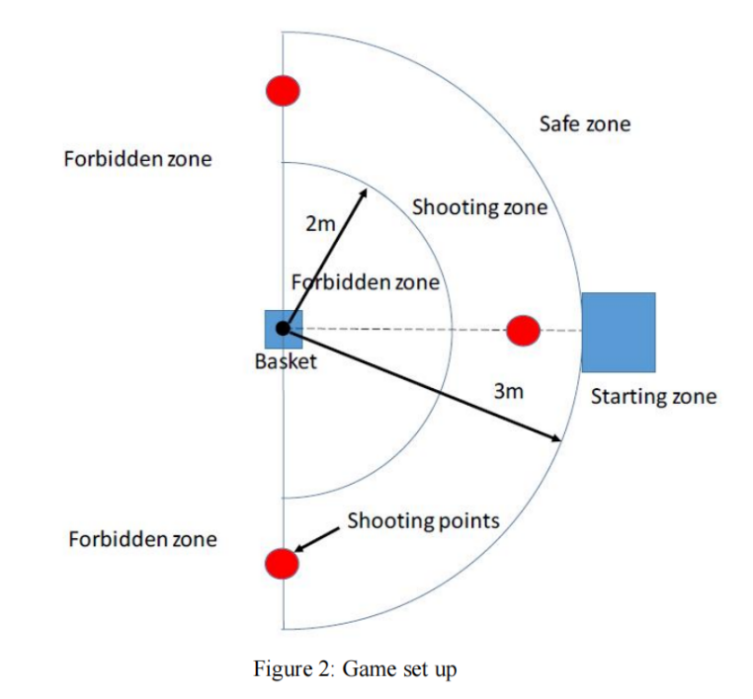

Figure 1 Game Set-up

From the game set-ups, we can conclude the three major technical issues are: electronic control, model design, prototype assemble and test.

# Concept Design

In this project, we are supposed to design and make an automatic metal trebuchet or catapult. The basic requirements for the catapult are as follows:

1. The prototype must be fit in a box of 35cm×20cm×35cm.
2. The prototype must be powered by at least one DC motor with batteries.
3. The prototype must be controlled by a remote controller.

In order to do the concept design, our group followed the instructions from lecture notes to generate our own idea.

Firstly, we made a Product Design Specification (PDS). As is shown here, this product design specification was made based on four parts, which are product identification, key project deadlines, competitor’s identification and physical description.

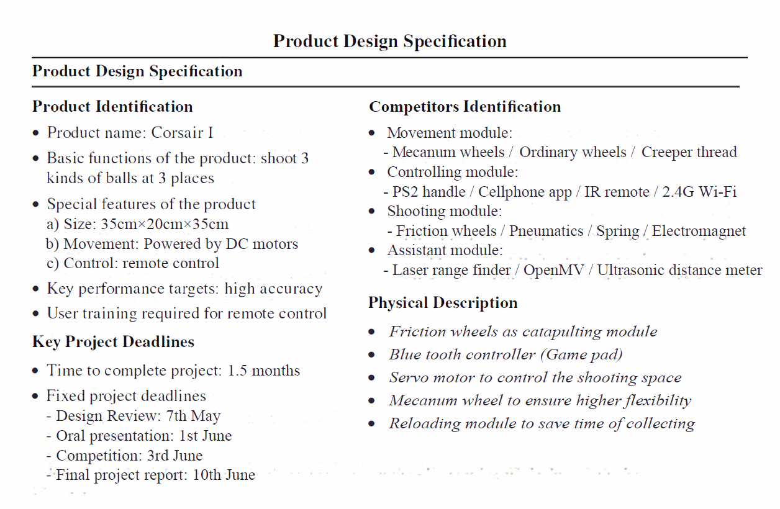

Figure 2 Product Design Specification

Secondly, for customer requirements (CRs), we listed a chart below from the course project guideline and course project description.

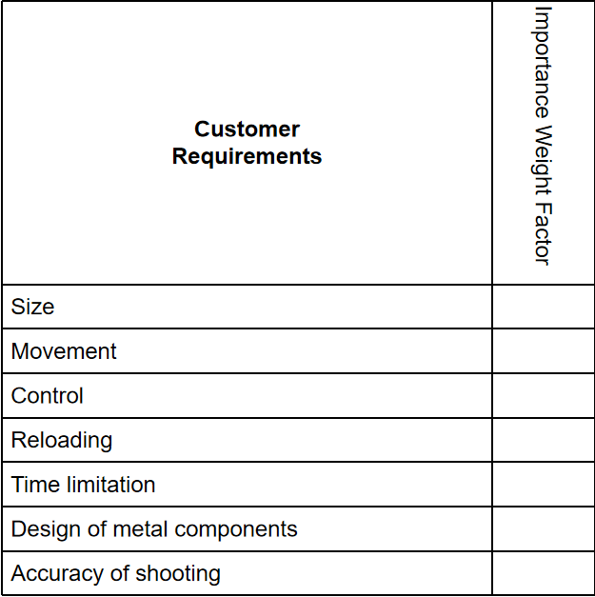

Figure 3 Customer Requirements

Thirdly, for Engineering Characteristics (ECs), our group had a brief brainstorm based on the two documents and generated the main content of this chart.

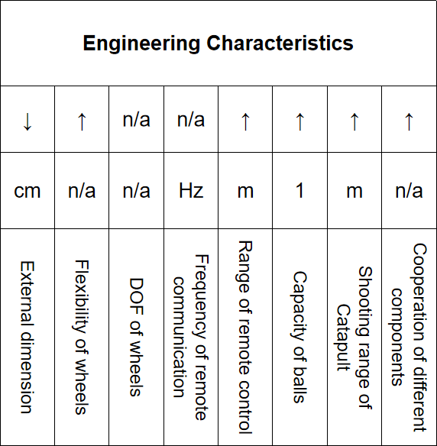

Figure 4 Engineering Characteristics

Finally, for Quality Function Deployment (QFD), we built a mini house of quality. All of our group members participated in the scoring procedure, the final score was the average participation of our group. In this little house of quality, it is clear from the score rank order that cooperation of different components, flexibility of wheels, and capacity of balls are the top three requirements that we should attach more importance to. To deal with them, we applied targeted measures: For “Cooperation of different components”, we increased our designers’ contact rate, holding frequent meetings to make sure everyone is on the same track and every component can match up with each other. For “Flexibility of wheels”, we chose Mecanum wheels as our major moving base. For “Capacity of balls”, we designed a special storage module, the ball clip, which can hold up to 5 ping-pong balls in it.

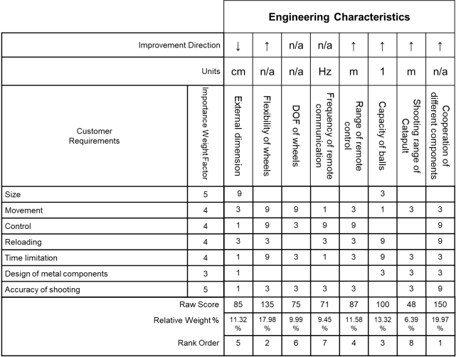

Figure 5 House of Quality

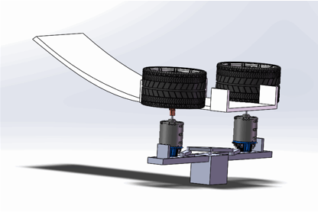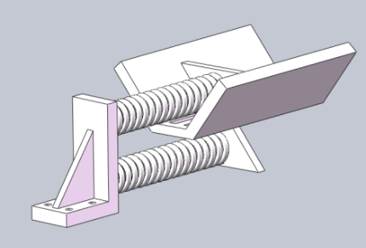Our concept generated from what has been stated above, for shooting device, we designed two different kinds of catapulting modules, one based on two strings, and the other based on friction wheels. By comparing these two designs in reality, we soon find that the first plan is not feasible, because the spring structure rebounds to its original length so slowly that it cannot generate enough impulse to shoot the balls into the basket.

Figure 7 Initial Design of Shooting Module II

Figure 6 Initial Design of Shooting Module I

For storage device, one of our groupmates designed a ball clip, which is used to hold and transmit ping-pong balls. The slope of the tube is specially designed to be very low in order for the balls to roll down slowly. And a six-blade component is used to transmit one ball at one time.

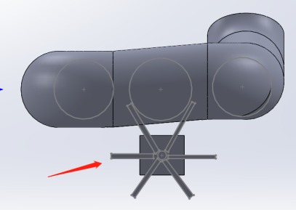

Figure 8 Storage Device (Ball Clip)

To adapt to different ball sizes, a special track was designed to restrict the space between two friction wheels. This device is driven by a 30kg servo motor and the track is lubricated to get rid of frictions.

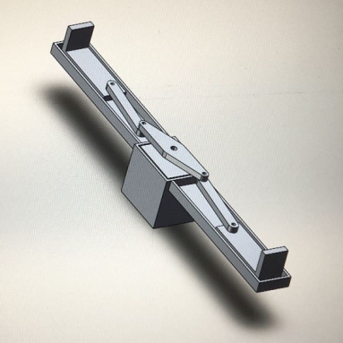

Figure 9 Distance Controlling Track

We selected plastic materials to reduce the weight of our catapult and made most of the components with the help of 3D printer. However, we used metal materials with special heat treatment to build the holding and supporting part. The chassis and the track of our prototype is designed in metal.

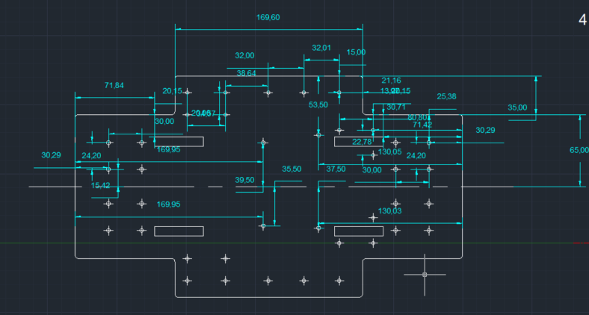

Figure 10 Design of the Chassis

The prototype design of our group is shown in the following figure.

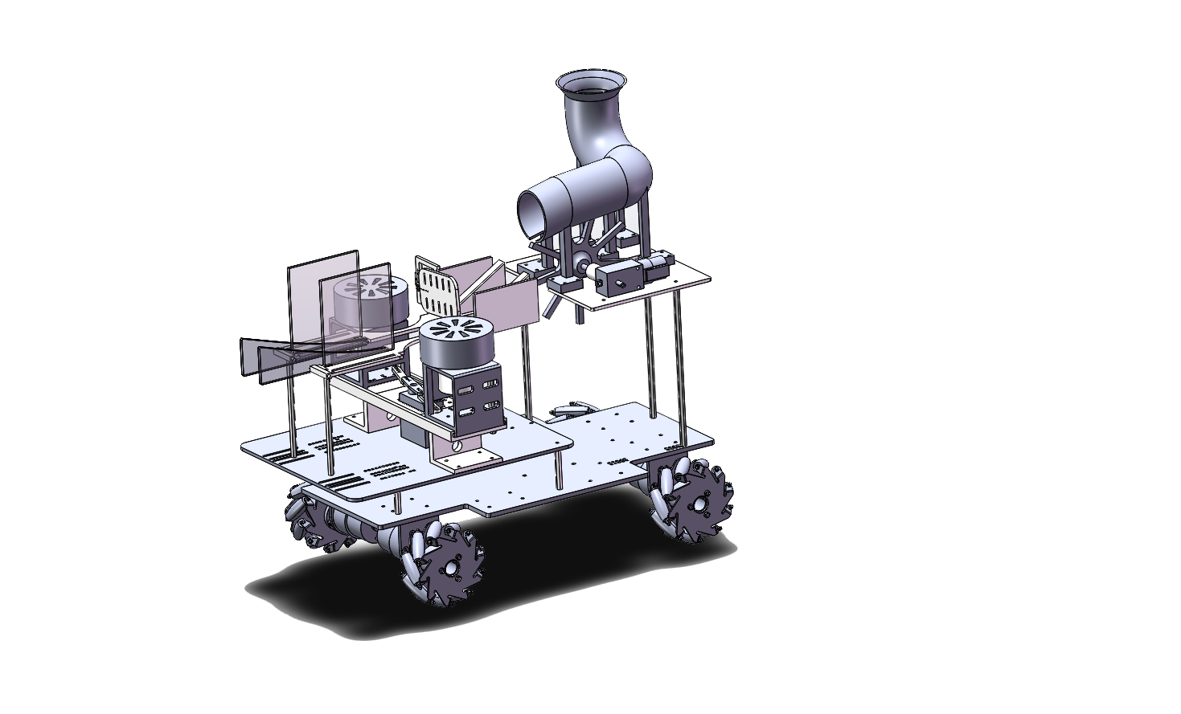

Figure 11 Whole Structure

# Manufacturing

## Electronic Control

In order to achieve the goal of the mission, we equipped many systems on the catapult. Since it requires remote controlling, the core part is its electronic control system (or control system). The components of the control system should have the function of power supply, signal transmission and reception, signal processing, electrical signal output and motor driving. The main components are shown as follows:

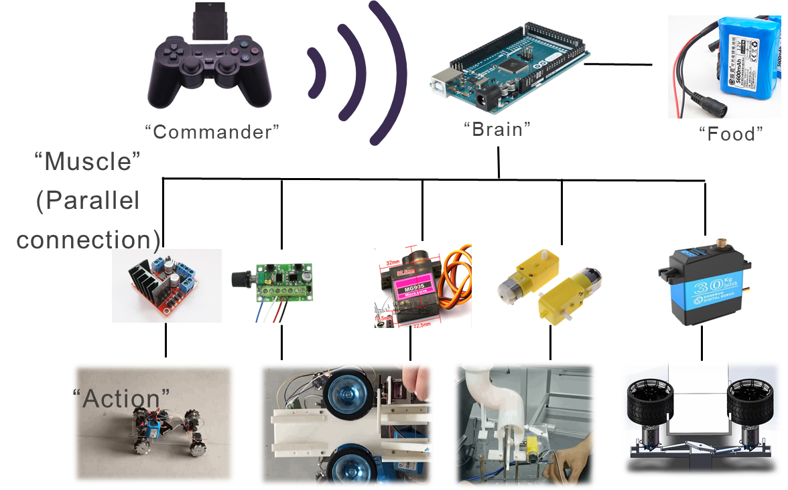

Figure 12 Structure of the Control System

Firstly, in terms of power supply, we need to analyze the components that run on electrical power. Signal transmitter on PS2 handle, signal receiving module, Arduino mega2560 motherboard, three L298N motor driving modules, one driver board for friction wheel motors, four DC motors of Mecanum wheels on the chassis, two friction wheel brush-less motors of 6000 rpm, one launching track baffle servo motor, one friction wheel space-control servo motor and a DC motor for reloading at the ball storage pipe (Their detailed parameters will be listed in the appendix). After analyzing and arranging the relevant parameters of various electronic components, we decided to use two 12V power supplies, one 7.4V power supply and two No.7 batteries to supply power for all components. The total working voltage of the whole car is less than 36V, which is within the safety voltage range of humans, so there is no hidden danger for users.

Secondly, in terms of signal transmission and reception, the PS2 handle signal transmitter uses Bluetooth communication, its communication protocol only supports one-to-one matching with the signal receiving module loaded on Arduino, and it has its own matching and reconnecting functions. The stability of 2.4G wireless connection and the high frequency communication channel ensure that the Arduino motherboard of the car can receive signals in time and give instructions to the driving module. Depending on this set of communicating equipment, we can implement accurate remote control of the car.

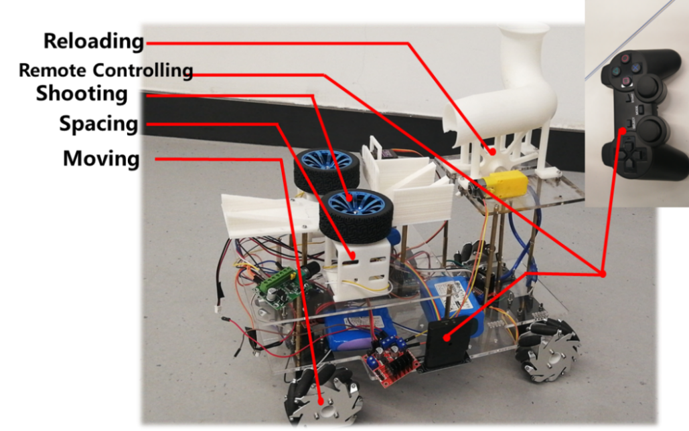

Figure 13 Control System on the Prototype

Thirdly, in terms of signal processing, we have uploaded the written program in Arduino Mega2560. The program in Arduino motherboard will judge and analyze the received signal from PS2 handle, judging from the conditional logic statement of “if” to command the specific motors within these driving modules after receiving signals. We enabled different functions to different buttons on the handle, which makes the car more operable and more intelligent.

Fourthly, in terms of the electrical signal output and motor driving, we use L298N driving modules for low-speed motors, and use the PWM function in Arduino motherboard to adjust instantaneous speed of each motor. For the motors of high-speed brushless friction wheels, we purchased and used the speed control board, and similarly, we use the PWM interface in Arduino motherboard to adjust the speed of them.

From what has been mentioned above, we can complete the overall deployment of the remote-control system and draw the following work flow chart.

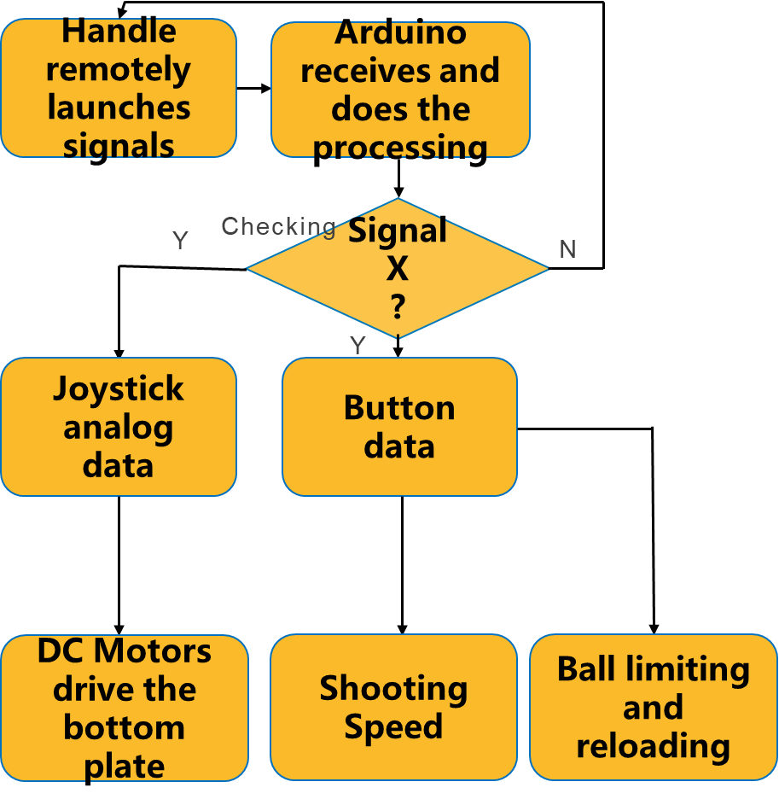

Figure 14 Logic of Control

### Joystick data processing

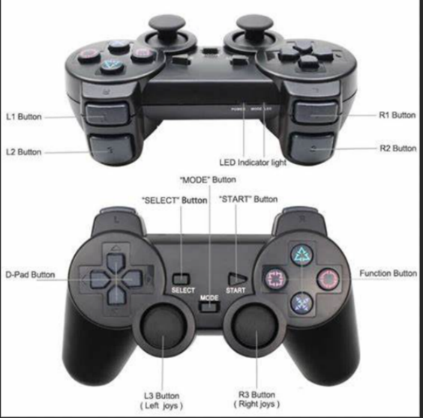

Figure 15 Buttons and Joysticks on a Handle

In order to use the wireless Bluetooth handle to control the car's movement, after learning the code of PS2 handle in the header file given by manufacturer, we use Arduino's serial monitor to obtain the data sent when the joystick is placed in different positions. After analyzing, we find that the position of the joystick is determined by a Cartesian coordinate system of X-Y plane, the values of X and Y varies from 0 to 255, meanwhile, the initial position of the joystick is X=128, Y=127. Therefore, we establish a Cartesian coordinate system with the initial position of the joystick at the origin.

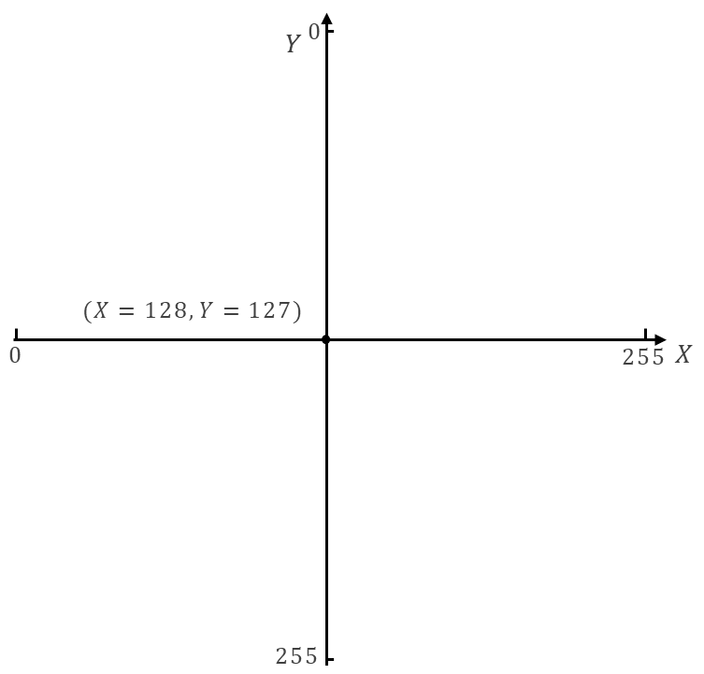

Figure 16 Coordinate System of a Joystick

Then, we divide the area of the coordinate plane into different quadrants, combining it with the function we want to achieve. That is, when the joystick is in a certain area of the plane rectangular coordinate system, the car executes the command of corresponding movement.

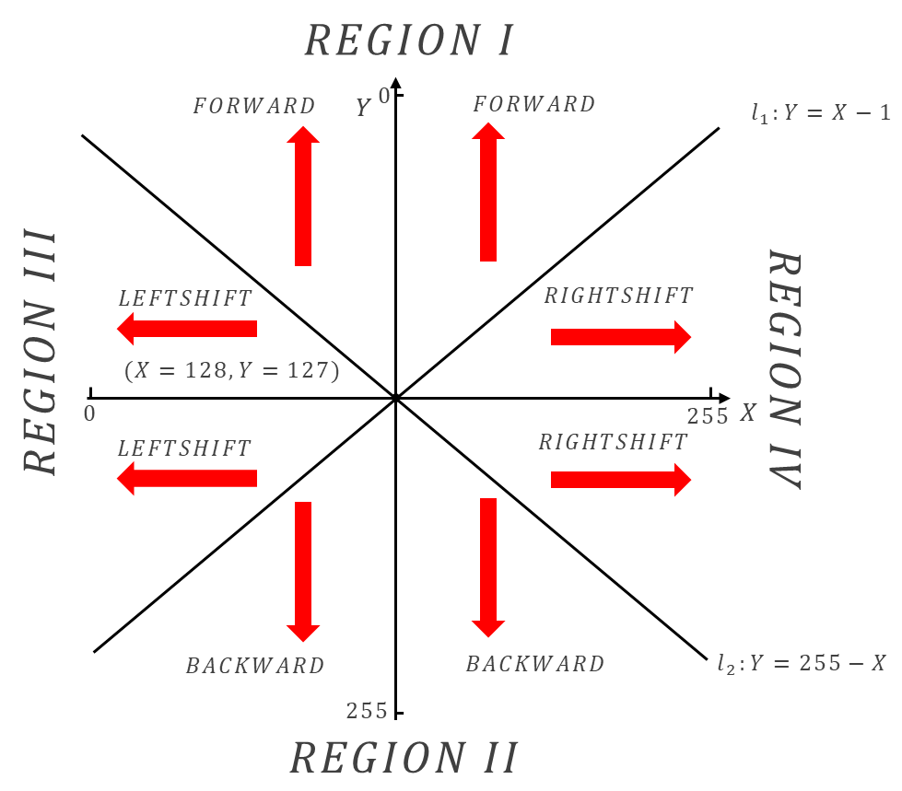

Figure 17 Region Separation of the Coordinate System

The whole joystick coordinate plane is divided into four quadrants. At the signal receiving terminal of Arduino, it reads the position of the left joystick all the time, and write corresponding conditional controlling statements. The pseudo code is as follows.

|  |
| --- |
|  |
|  |
|  |
|  |
|  |
|  |
|  |
|  |
|  |
|  |

According to the logic listed above, we have completed the remote-control code of the joystick to control the car movement, which makes full use of the advantages of Mecanum wheel structure and greatly improves the flexibility of the car.

## Three major parts



### Mobile device

Mobile device Settings is to make the car can be carried out in accordance with the instructions to move or rotate. We use the Mecanum wheels as a functional structure, which is an omnidirectional wheel, it can realize various movements, including forward, horizontal, oblique, rotating and their combination. Therefore, it is able to be faster and more efficient to achieve the task of moving in a specified small area.

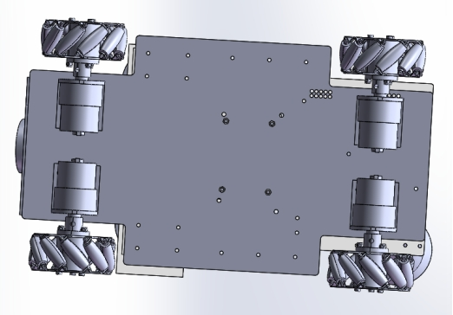

Figure 18 Model of Mecanum Wheels

### Reloading device

We are expected to only put ping-pong balls in the reloading device, which can contain 5 ping-pong balls at a time. Therefore, we designed the storing device into a curved round pipe and the L-shaped structure enables it to increase the capacity of ping-pong balls as much as possible in the limited space. In addition, the outlet of the pipe is set with a certain angle of inclination, so that the ball can overcome the friction of the pipe and freely fall to the corresponding position, which makes the propeller successfully get stuck to the ball. Then the specific function of controlling the balls is realized through the way that after the hollowing out the outlet of the pipe and installing a propeller, rotate the propeller by driving a motor to achieve the movement of ping-pong balls.

|  |  |
| --- | --- |
|  |  |
| (a) L tube | (b) Propeller |

Figure 19 Ball Storing Device

### Shooting device

In order to make the launching distance meet the requirements, we need to give balls a high enough rate of fire, and the approach we adopt is high-speed-running friction wheels achieve the friction launch. Its principle like this: after open the baffle and one ball just contact with two friction wheels, through a pair reaction of friction wheels rotating in the opposite direction that the friction and pressure, the ball will be accelerated out.

Therefore, the ball's launch speed is related to the magnitude of friction, contact time and ball mass. When the ball launch distance is not far enough, we will try to reduce the distance between the two friction wheels, so as to increase the friction force in contact and achieve the promotion of launch speed. Here in order to realize the sliding of friction wheels and meet the requirements of adjusting the distance between them, we also designed the corresponding structure. Make upright two friction wheel and motor structure installed on a slide, 30 kg of steering gear in the center of the slide is a connection to two connecting rods, and connecting rod ends respectively is fixed on the friction wheel motor bracket, therefore, we can drive the steering gear to pull the connecting rods, which makes two friction wheels taxi straight movement.

|  |  |
| --- | --- |
|  |  |
| (a) Friction wheels | (b) Linkage-rod |

Figure 20 Shooting Device Based on Friction Wheels

The shooting device is also equipped with the design of the trajectory orbit, which aims to ensure that the angle and direction of the ball can be controlled to the greatest extent during launch. In the front of the friction wheels, left and right sides of the slots are set for vertical placement of acrylic baffle. The spacing of the slots is confirmed according to the diameter of ping-pong balls and tennis balls, which is accessible to change the flashboard to adapt to different diameters of the balls when shooting out of different types of balls.

In addition, after multiple launch experiments, we expected to control the ball's shooting angle at about 45°, so we also used the acrylic plate to create a groove launch orbit with an inclination of about 45°. The design of the groove makes the center of the ball controlled in the center when passing through this section of trajectory as much as possible. In addition, the incident Angle can be controlled at about 45° as the ball can be close to the orbit when launching.

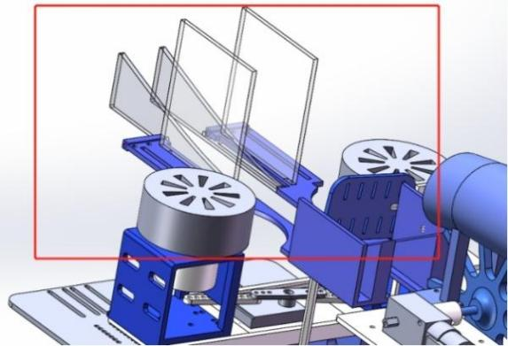

Figure 21 Guiding Track

## Material Selection

Except for standard components such as screws and nuts, the structures in this prototype are all made with 3D printing technology, and the material is therefore resin or PLA. However, for the chassis of the prototype and the slide rail that carries the launcher, we used metal parts.

As for the chassis, it needs to bear the weight of all of the components except the driving module (i.e., Mecanum wheels), which weighs 1.5kg or so. If a 3mm acrylic plate is used as the material of the chassis, with Solidworks used for finite element analysis, the central deformation can reach up to 0.8 mm. However, if the same thickness of 45C steel is used, its maximum deformation can be reduced to 0.01mm. That is to say, there is almost no deformation in this case. Therefore, for the sake of stability of the overall structure, 45C steel is the better choice for the material of the chassis.

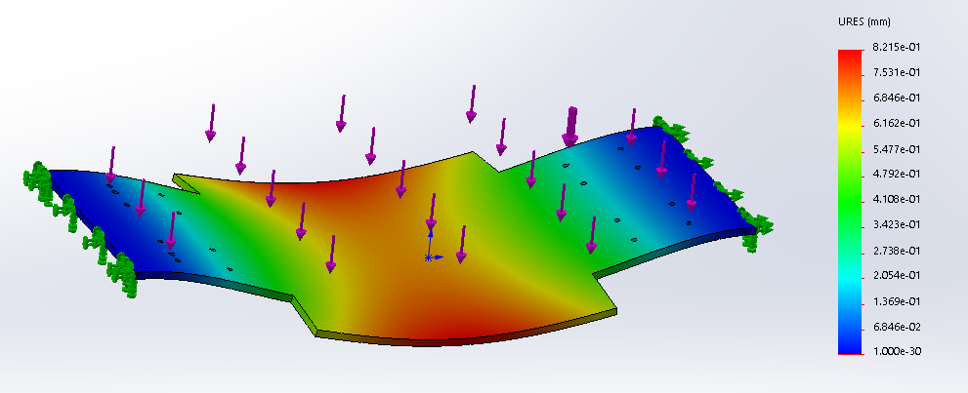

Figure 22 FEA of the Chassis (material: acrylic)

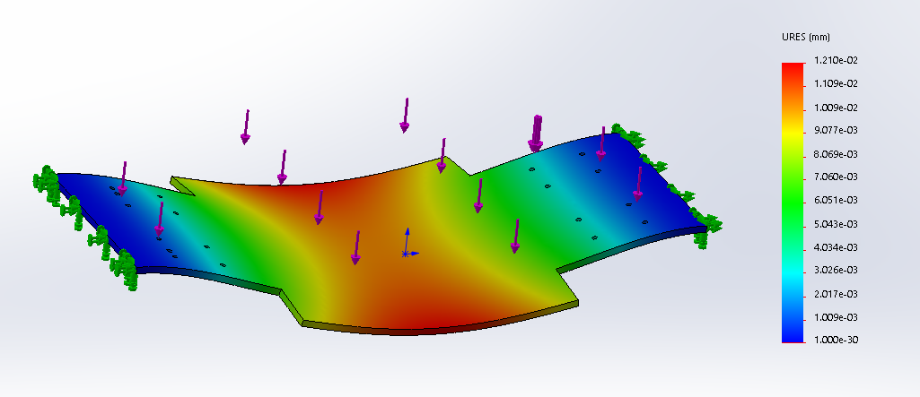

Figure 23 FEA of the Chassis (material: 45#steel)

Besides, the sliding rail which supports the launching device also needs to bear a relatively large force. More importantly, the sliding rail should have a smooth surface to reduce friction force to facilitate the sliding movement of the friction wheel space controlling device on the track. If 3D printing is used, the surface of the obtained parts is so rough that it is not easy to carry out subsequent processing. Therefore, stainless steel is used as the material of the slide rail, and the drawing surface treatment is adopted at the same time.

## Details of Design and Assemble

In our design and model assembly process, there are some important details which is worth paying attention to. Only when the designs are reasonable, can the functions of the prototype be implemented successfully.



### Space Adjustment Mechanism of the Friction Wheel

This mechanism mainly includes a sliding rail for carrying the launching device, two linkage rods, two brackets of the motor and a servo motor. The arm of the servo motor stretches out from the center of the slide rail. Two ends of the rod are respectively connected to the two ends of transmission rods, and the other ends of the two transmission rods are respectively connected to two motor brackets. When the servo motor runs, the motor bracket is driven to move on the slide rail through the transmission rod, and the two friction wheels will approach or move away from each other, so the space of them can be controlled accurately.

The focus of the design of the mechanism is to reduce the friction between the motor bracket and the slide rail, and to improve the mechanism's resistance to the stress generated when the friction wheel contacts the ball.

To reduce friction, one way is to insert balls on the two ends of the motor bracket and the sliding rail, and use rolling friction to replace sliding friction (as shown in the figure);

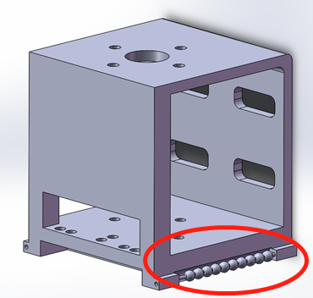

Figure 24 Motor Bracket

The second way is to install the transmission rod at the bottom of the motor bracket near the edge. As shown in the figure below, it is a schematic diagram of different forces corresponding to different installation positions of the transmission rod. The transmission rod shown in Figure (a) is installed at the center of the bottom of the motor bracket, and the transmission rod shown in Figure (b) is installed at an eccentric position of the bottom of the motor bracket. With the servo motor exerting the same pulling force on the transmission rod, when the motor bracket is pulled to the same position, due to the difference in the angle between the transmission rod and the horizontal direction, the force component of the pulling force along the normal direction differs (i.e., the normal compression forces that motor bracket produces on the rail wall differs). Obviously, the normal compression forces is smaller in the situation shown in Figure (b). The smaller the normal compression forces, the smaller the friction between the motor bracket and the slide rail.

|  |  |
| --- | --- |
|  |  |
| (a) | (b) |

Figure 25 Force Analysis for the Motor Bracket

Owing to the two modifications above, and applying lubricating oil on the contact surface of the motor bracket and the slide rail at the same time, the friction can be effectively reduced.

To make sure the prototype can withstand the impact force generated when the friction wheel is in contact with the ball, we strengthen the motor bracket, cooperating with the slide rail and the motor bracket. As shown in the figure below, since the ball obtains its kinetic energy from the friction generated between the friction wheel and the surface of the ball, when launching the ball, the distance between the two wheels should be slightly smaller than the diameter of the ball (for racket balls that are prone to deformation, the distance between the two wheels should be smaller) to increase the normal stress and generate enough friction to prevent the ball from slipping between the two friction wheels. At the moment when the ball is in contact with the friction wheel running at high speed, the ball will exert a relatively large force on the friction wheels on both sides (as shown in the figure below), and the motor bracket will receive a shear force. Easy to fall off from the track; if the motor bracket itself is not stable enough, it is easy to bend or even crack, which affects the stability of the launch.

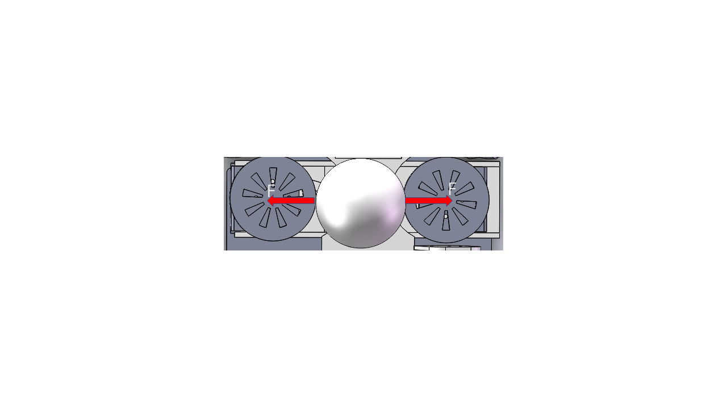

Figure 26 Horizontal Forces Exerted by the Ball

To this end, the first method we took was to dig grooves at both shoulders of the slide rail, and design a corresponding cubic protruding structure that can be inserted into the groove on the motor bracket (as shown in the figure). The groove is used to limit the movement of the motor support in vertical direction.

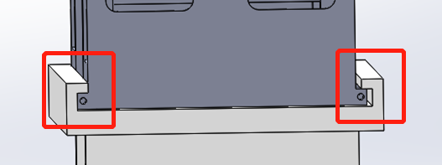

Figure 27 Details of the Assemble between Track and Bracket

The second method is to design the motor support into a square-shaped structure (as shown in Figure (b)). Although this structure is more expensive than the C-shaped structure (as shown in Figure (a)), which can also achieve the function, and it costs more materials and increases the difficulty of assembly as well, but under the influence of the same magnitude of shear force, its deformation will be far much smaller than the C-shaped one.

|  |  |
| --- | --- |
| bfdcedef7f2fff46582799fd7493ff7 |  |
| (a) | (b) |

Figure 28 Static Stress Analysis of Two Designs of Motor Bracket

### The Ball’s Guiding Track

The ball's motion guiding track is shown in the following figure. It can be divided into two parts. One is to guide the ball into the direction of the vertical bisecting line of the friction wheel connection between the two friction wheels, and the other is to guide the ball to shoot straight ahead and do oblique throwing.

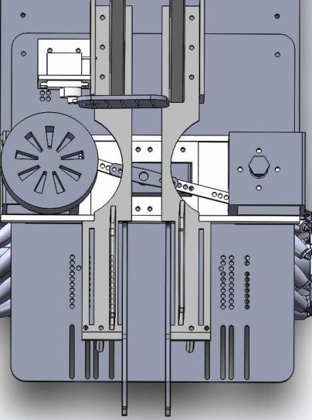 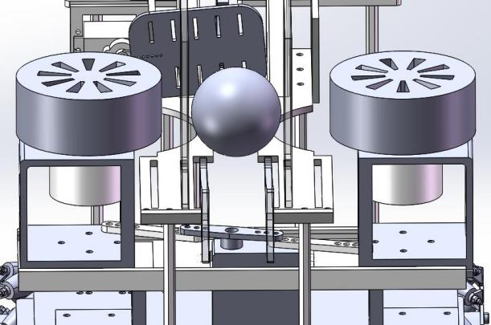

Figure 29 Overall View of Ball’s Guiding Track

For the first part of the track, we adopt a groove structure (as shown in the figure) to limit the center of the ball to always fall in the middle of the track. The advantage of adopting the groove structure is that it can adapt to balls of different sizes. The size of the ball is different, and the height of its sinking is different (as shown in the figure), but the center of the ball will always be in the middle of the track.

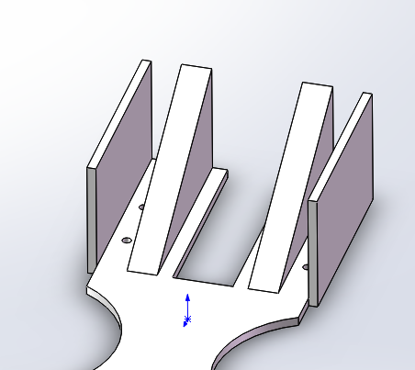

Figure 30 Ball’s Guiding Track (part I)

In addition, since the width of the groove should be smaller than the diameter of the smallest ball, and the diameter of the tennis ball is much larger than the diameter of a ping-pong ball and a rocket ball, when the tennis ball falls on the groove, the sink height will be small. It is possible to slide out of the groove, so on both sides of the track, we add baffles to limit the movement of the tennis ball in case of its falling off the track.

|  |  |
| --- | --- |
|  |  |
| (a) Ping-pong ball | (b) Tennis ball |

Figure 31 Diagrams of Track with Different Balls

Even if the ball is in the middle when it enters between the two friction wheels, due to the uncontrollable subtle differences between the two sets of motors and the friction wheels, the ball may not be completely straight ahead during the ejection process. Therefore, the second part of the track also needs to restrict the movement of the ball along the center line. Since the speed of the ball is extremely fast after being accelerated by the friction wheel, the guiding structure mentioned above cannot achieve the goal of limiting the shooting direction of the ball. Therefore, we designed the second part of the track as a track with detachable baffles on both sides as shown in the figure below. (As the picture shows). The baffle is made of acrylic board, which can be easily inserted in different grooves of the track to adapt to balls of different diameters.

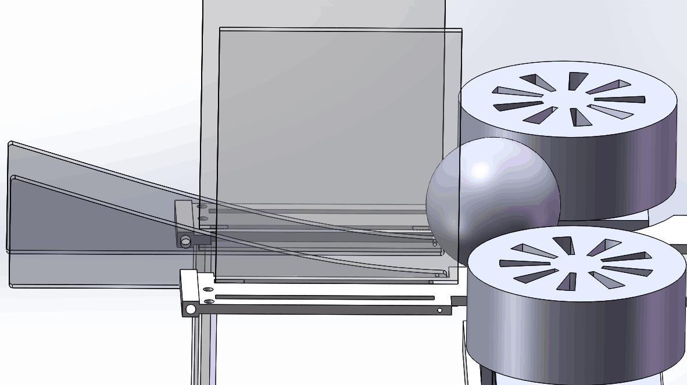

Figure 32 Ball’s Guiding Track (part II)

### Reloading System

This part consists of a pipe for storing ping-pong balls and a propeller-type rotating structure (as shown in the picture).

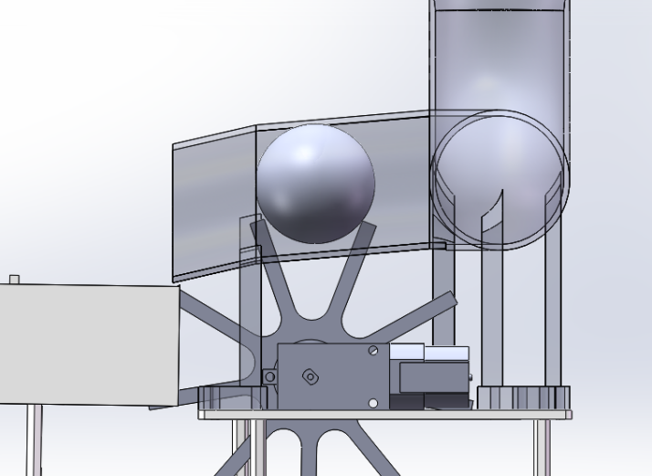

Figure 33 Transparent View of the Reloading System

This system has higher requirements for assembly, because when the ping-pong ball enters between the two adjacent rods of the propeller, the ball will be raised up, which may touch the inner upper wall of the pipe. If the length of the propeller rod extending into the pipe is too long, the height of the ball being lifted will be too high, it will be in contact with the propeller, generating a resistant force and making the propeller device unable to rotate in the counterclockwise direction, and thus the ball cannot be transported out of the pipe. The depth of the propeller rod entering the pipe is difficult to calculate, and it is a relatively quick and convenient method to determine through testing. Therefore, we choose to achieve a better fit between the two by fixing the installation position of the propeller and using nuts to flexibly change the height of the pipe relative to the propeller (as shown in the figure).

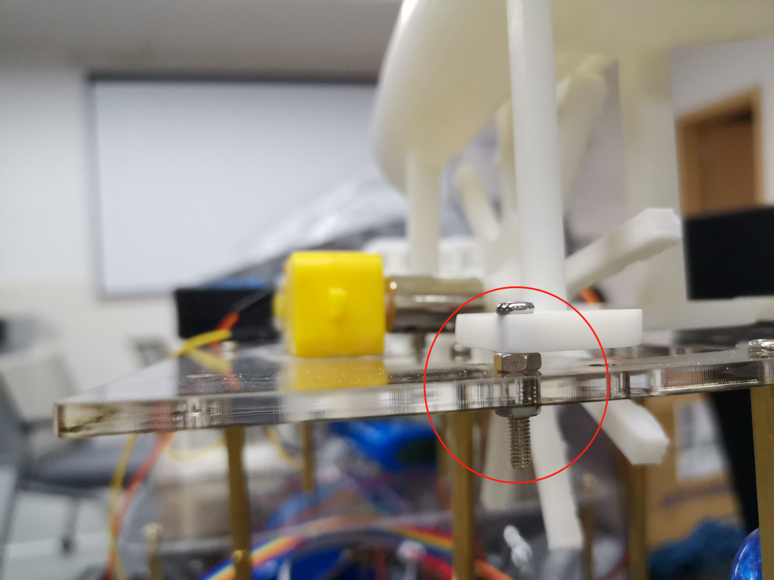

Figure 34 Use of Nuts in assemble

# Cost Estimation

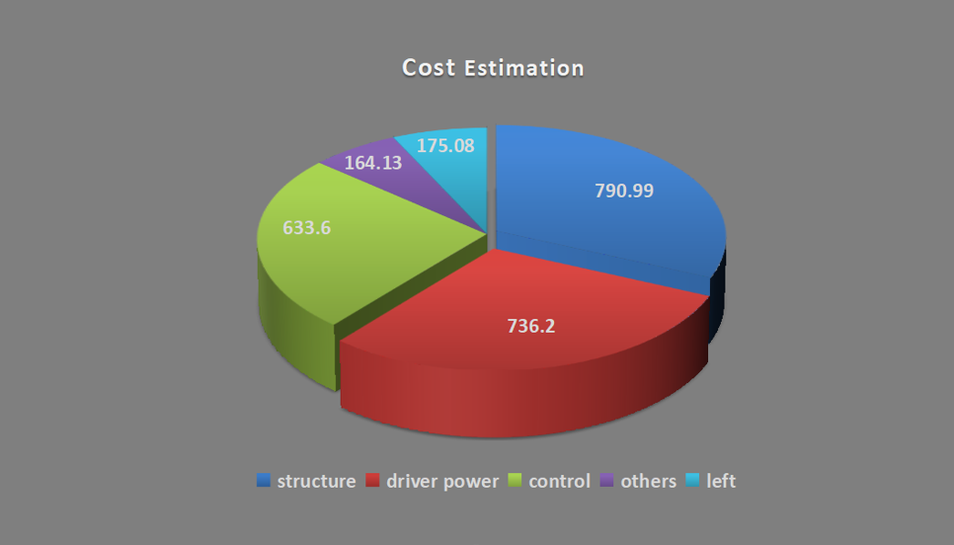

Figure 35 Overview of the Expenditure

Our group’s cost estimation is divided into three main parts, structure, drive power and control. The rest is the cost of some small things and we still have 175 yuan left. (Total budget is 2500 yuan)



## Structure

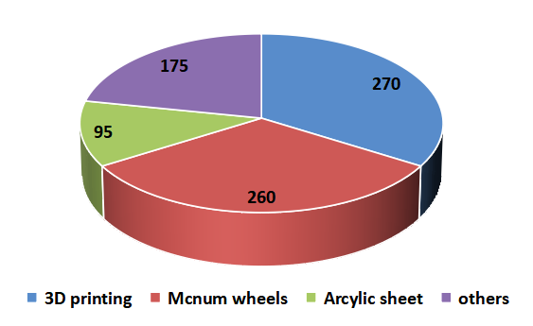

Figure 36 Expenditure on Structure

The most expensive part is the structure, which cost 790.99 yuan. Of that, we spent 270 yuan on outsourced 3D printing, 260 yuan for Mecanum wheels, 95 yuan for Acrylic sheet and the remaining is spent on the items such copper columns.

## Power System

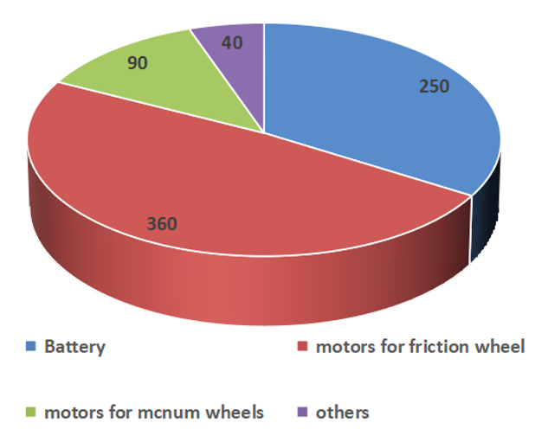

Figure 37 Expenditure on Power System

The second biggest cost is drive power, about 736 yuan, of which 250 was spent on battery, 360 yuan was spent on motors for friction wheel, 90 yuan was spent on the motors for Mecanum wheels.

## Control

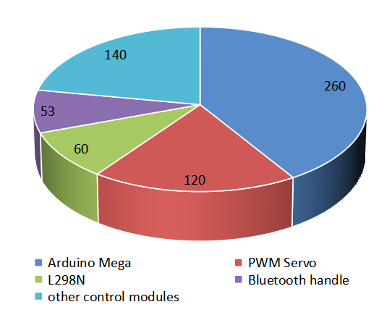

Figure 38 Expenditure on Electronic Components

The third biggest cost is the control part, which is about 640 yuan. It includes various control components.

# Conclusion

In this project, we’ve gone through the entire process of design and manufacture of our project. From initial concept design through manufacture to budget arrangement. We accomplished the project following the guidance of the course materials. We are very happy that we can apply what we have learnt to what we are doing. What makes us even happier is every single time when we came across and overcame those difficulties in the end. Of course, there are still some points that we can do better if we have extra time and money, but we’ve devoted what we have to make it as good as possible, and that’s the point.

# References

2021 Vm250 Course project description

# Nomenclature

CRs—Customer requirements

ECs—Engineering Characteristics

PDS—Product Design Specifications

HOQ—House of Quality

FEA—Finite element analysis

# Acknowledgement

Special thanks for the sponsor of our university and for the instructor’s and TA’s kind help. Also, we appreciate the generous help from our classmates whenever we are in trouble.

# Appendixes

|  |
| --- |
| Appendix I |
| Introduction: All sketches in concept design |
| First-generation    Second-generation |

|  |
| --- |
| Appendix II |
| Introduction: All engineering draws with Solidworks |
|  |

|  |
| --- |
| Appendix III |
| Introduction: Product Design Specifications |
|  |

|  |
| --- |
| Appendix IV |
| Introduction: Details of Prototyped machines |
| |  |  | | --- | --- | | Details | Photo | | Space Control Device |  | | Reloading Device |  | | Mecanum Wheel |  | | Transmitting Propeller |  | | Shooting Module  &  Guiding Track |  | |

|  |
| --- |
| Appendix V |
| Introduction: Other related works |
| |  |  |  | | --- | --- | --- | | Components | Parameters | Photos | | Motor Controller Board | 6-30V |  | | L298N Driving Board | 5V, 25W |  | | Friction Wheel Motor | 12V 2.5W |  | |